Reusable Shopping Trolley Bags (Set of 4)
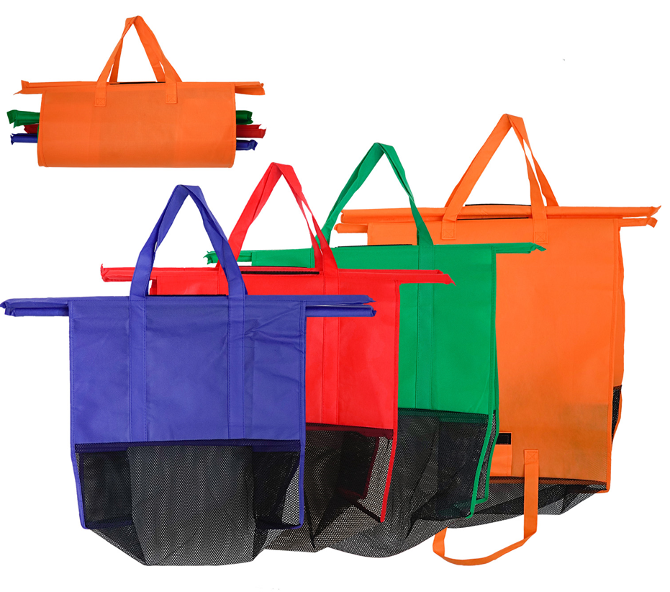

About this item
- Set of 4 Eco Friendly Reusable Shopping Cart bags
- Compact 4 in 1 bag set that’s easy to use from Cart to Car
- Make your grocery shopping effortless, no more plastic or paper.
- Large Insulated Blue Bag for Hot/Chilled or Frozen Products
- Made from Strong washable material

Shopping Trolley Bags
These Reusable Shopping Trolley Bags will offer you the most organized grocery shopping experience ever! You can save so much time and effort while also helping our planet to eliminate waste and the use of plastic. You can already sort everything while putting them in your cart. Super environmental friendly!

Reusable Bags
Help the environment and our planet to eliminate waste products and the use of plastics. These reusable bags can be used for long years. All you need is just a little effort of bringing it with you everytime you go on grocery shopping. A little effort but makes a big difference in saving our planet.
Very easy to bring as it can be folded when not in use. Has a convenient handle too so you can carry it easily.

Smart Design
It has 4 different sizes which are specially designed to fit in grocery carts. Sort every product as you go. And it will be quicker for you too when paying to the cashier. It will be a lot easier now that everything is already packed and sorted. You can finish shopping quicker than before.
Every bag has a practical handle so you can easily transport them from cart to your car. Each bag also has different colors for easier sorting solution. You can easily identify which products should go together. You can easily sort your dry goods, meat, toiletries, and more. Also having different separated bags makes it easier for you also to organize everything you bought when you get home.

- Size:53x26x50cm
- Package size per batch: 67X25X62 cm
- Gross weight per batch:9.810 kg
- Material:Non-woven, 120g, Non-woven 120G

- Part number: SHPG-BGS

